# Using the SENNA SRL Parser

SENNA is a very fast SRL parser, created by Ronan Collobert, et al. SENNA stands for Semantic Extraction using a Neural Network Architecture.

### 1. Download SENNA.

See the download link on the main page to download the zip file:

<http://ronan.collobert.com/senna/>

This download includes binaries for linux, mac, and windows. It also includes source files if you need to compile.

Unzip the download wherever you want to keep it. I have a folder called “nlp_tools” on my disk where I keep software like this. The extracted folder will take up about 250 MB on disk.

### 2. Sanity Check.

From the console, type the following, replacing “senna” with senna-linux64, senna-win32.exe, or senna-osx.

./senna –posvbs

Then type in a sample sentence and see the results (ctrl-c to quit):

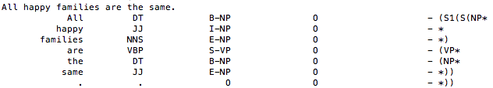

The posvbs flag treats verb ‘be’ like any other verb. There are other flags you can read about in the senna link above.

### 3. Redirect to/from input and output files.

The following example took input sentences from input.txt. It is recommended to put one sentence per line in order to make the output more readable.

To print to console:

./senna –posvbs < input.txt

To redirect the output to a file:

./senna –posvbs < input.txt > output.txt

